WEB DASHBOARD NODES FOR CREATE UI

|  |  |
| --- | --- |
| Date | 14 November 2022 |
| Team ID | PNT2022TMID42038 |
| Project Name | Project – IOT Based Real – time River Water Quality Monitoring and Control  System |
| Maximum Marks | 4 Marks |

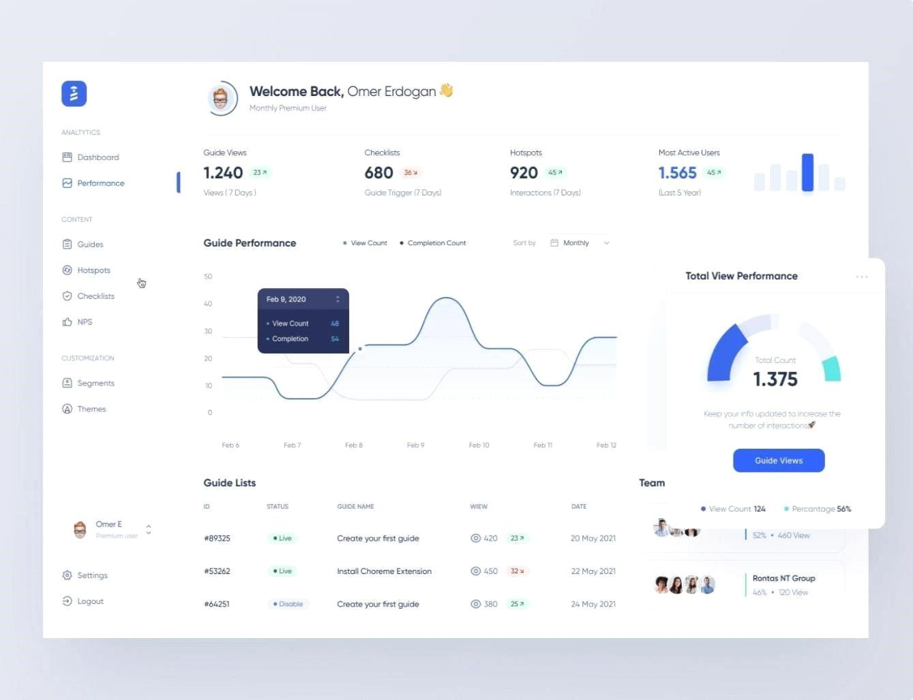

If you design a proper and modern UI dashboard, it will give the users easy access to the information they need. For this to happen, the dashboard information needs to be easy-to-scan and contain only the key information. But, with many tools available, it can be

hard to make the right choice or not exaggerate with the use of features.

This is one of the many**[HYPERLINK](https://adamfard.com/blog/ux-designer-role) ["https://adamfard.com/blog/ux-designer-role"roles of a UX](https://adamfard.com/blog/ux-designer-role) [designer HYPERLINK "https://adamfard.com/blog/ux-designer-](https://adamfard.com/blog/ux-designer-role) [role"](https://adamfard.com/blog/ux-designer-role)** [HYPERLINK "https://adamfard.com/blog/ux-designer-role"a](https://adamfard.com/blog/ux-designer-role)nd as such, it demands knowing certain tricks to be handled the right way.

